****

To whom it may concern,

I fully support the proposed research described in the proposal by Ross-Ibarra, Hufford, and Coop.  I am happy to collaborate and participate in this research. My role in this grant is to carry out part of the work of Aim 3.4 in Gene Expression. I will aid in the common garden experiments and contribute with analyses of the transcriptome data generated for this goal.

Please do not hesitate to contact me if further information is required.

Sincerely,

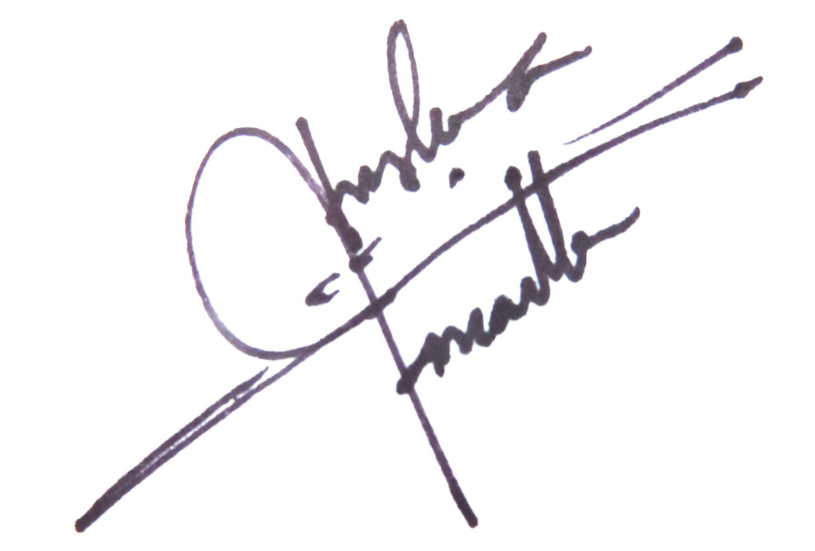

Angelica Cibrian Jaramillo, PhD

Ecological and Evolutionary Genomics

LANGEBIO-CINVESTAV

Km 9.6 Libramiento Norte Carr. Irapuato-León

C.P. 36821, Irapuato, Gto. Mexico

acibrian@langebio.cinvestav.mx

Tel. +52 462 1663014